Topic: Predicting Box Office Revenue of a Movie

With the advent of social media, the behavior of people is no longer an isolated action, allowing analysts to make predictions. The entertainment industry is one of the biggest industries in terms of the number of consumers and revenue involved. Analyzing tweets posted by the general population can be used to predict the box office revenue of a movie. The purchase intentions of users, comments of users, and popularity, as well as attention of the movie, is focused upon to gauge a movie’s potential success (<https://link.springer.com/article/10.1007/s11042-014-2270-1>).

A proposed plan for extracting data from Twitter:

(<https://www.researchgate.net/publication/282854576_Using_Twitter_Data_to_Predict_the_Performance_of_Bollywood_Movies/link/563836da08ae78d01d3953b9/download>)

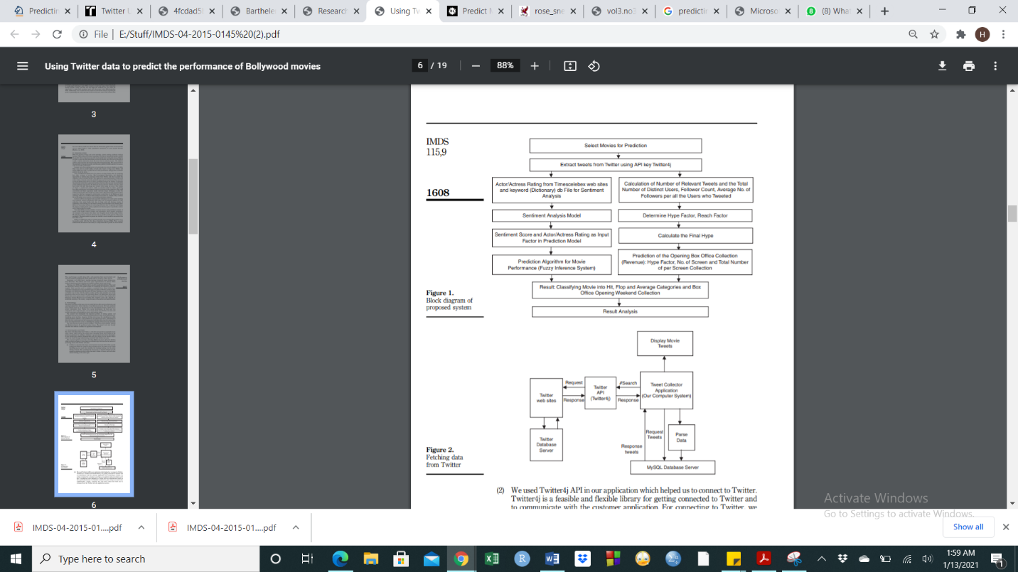

Several different methodologies can be employed to deduce the monetary progress of the movie.

* There are 7 factors considered while predicting the revenue as mentioned below:

1. Polarity ratio (Polarity = Pos/Neg)
2. Hype = (No. of distinct users/ total no. of users who tweeted) + Rate of Tweets
3. Actor
4. Holiday effect
5. Genre
6. Sequel

(https://pdfs.semanticscholar.org/93a6/4fcdad5bb3a69eaa314688f8824f6779ad6e.pdf)

* Sentiment Analysis Model:

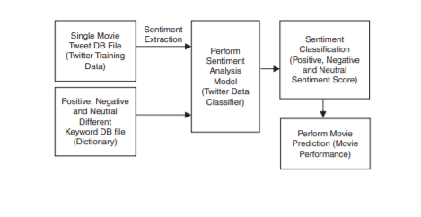

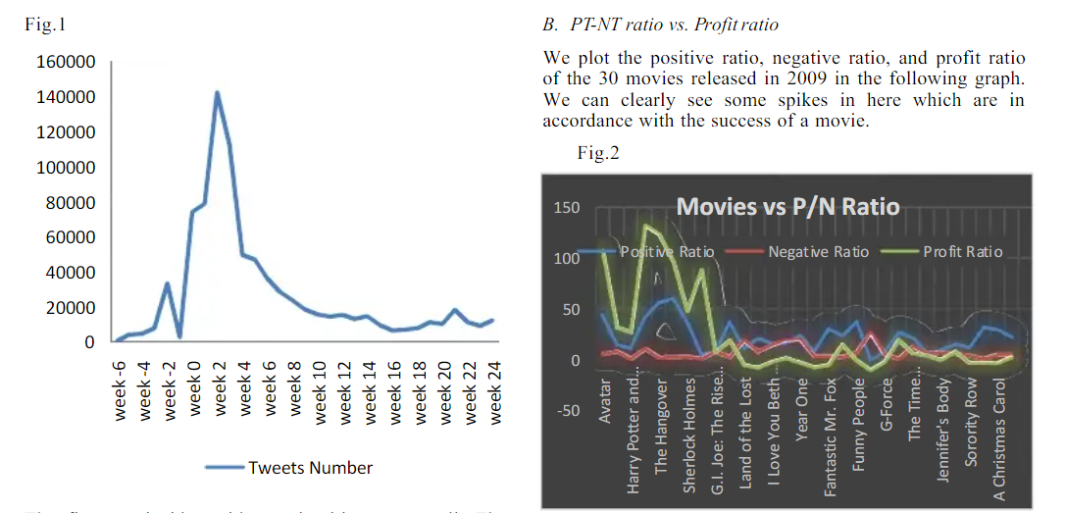

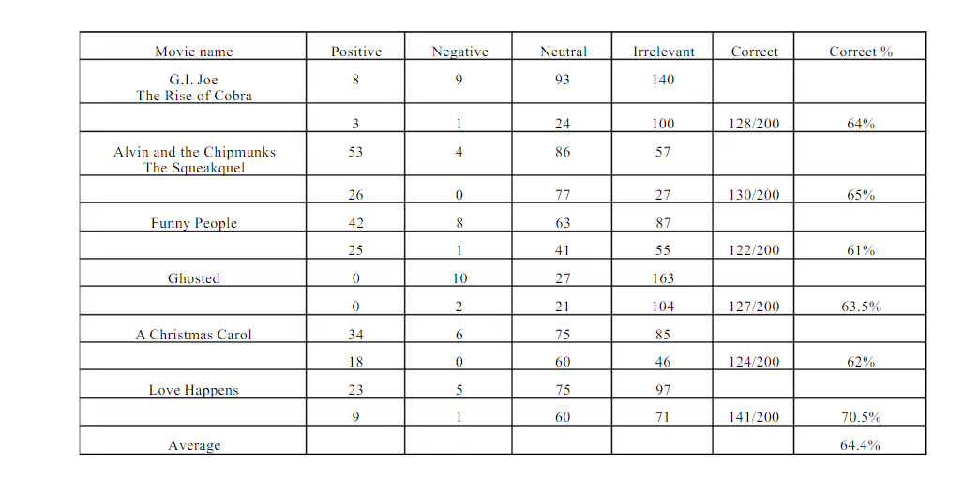

* One of the most accurate approaches is to follow the Hollywood Stock Exchange, a market where people buy and sell virtual shares in actors, directors, and individual movies. An increased number of shares predicts higher revenues for a newly released movie.
* A correlation between the sentiment scores of tweets and stocks purchased can be used to establish the validity of the results derived from the tweets (<https://mmss.wcas.northwestern.edu/thesis/articles/get/783/Harley2012.pdf>).

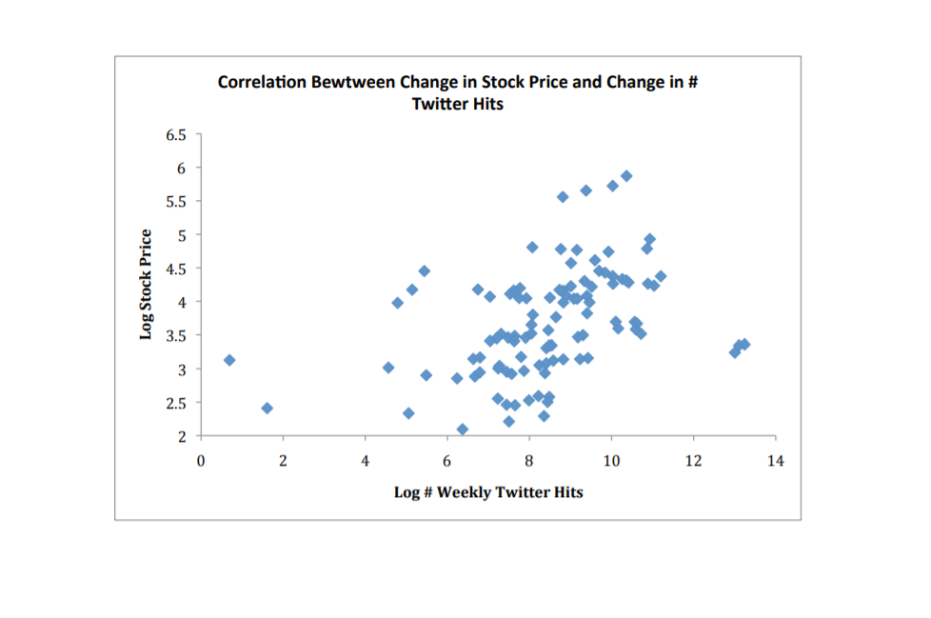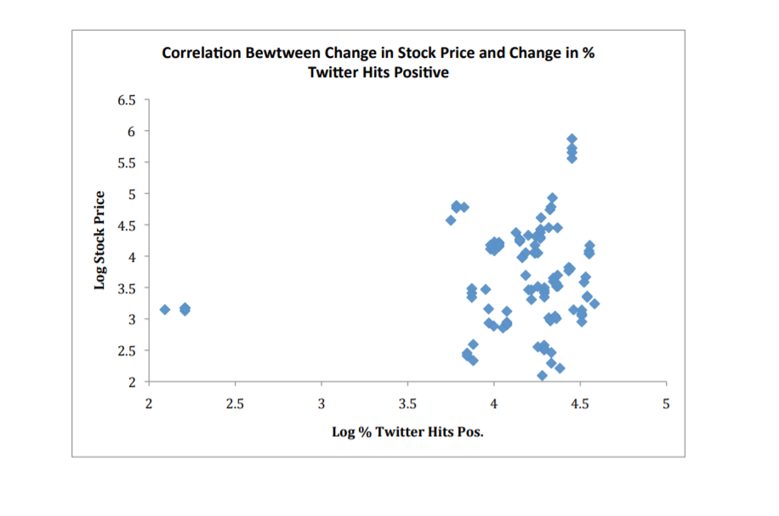

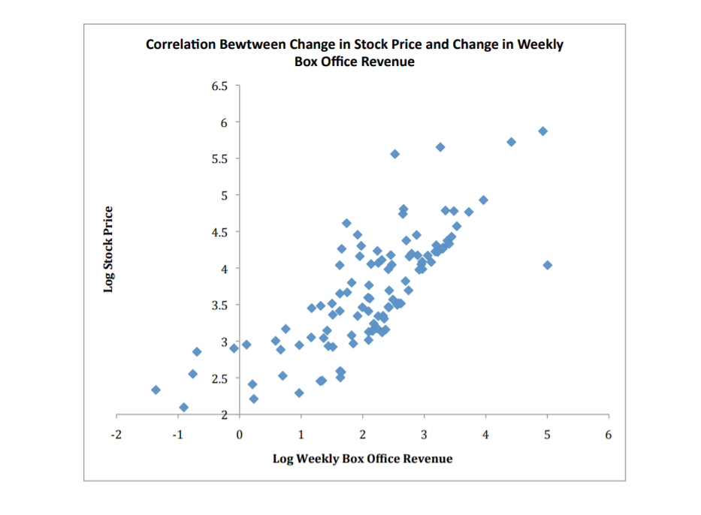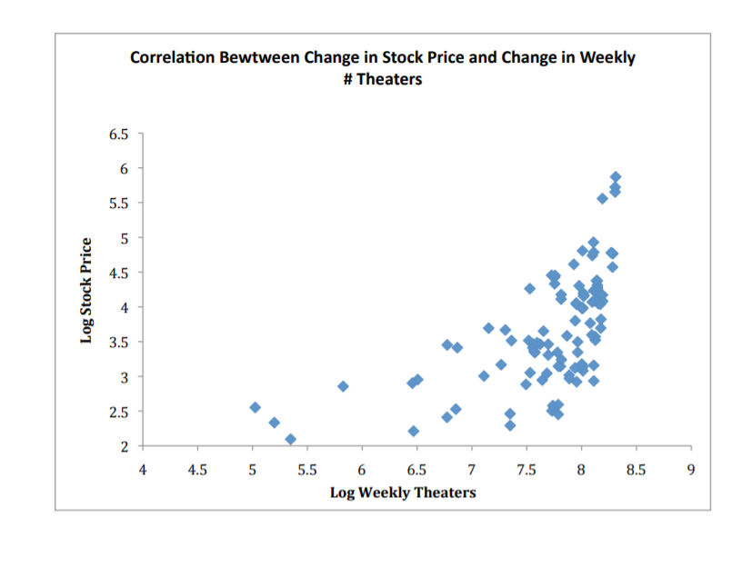

**Topic discarded**: Analysis does not provide a meaningful contribution and limited impact.